Seneca United Methodist Church
MARCH 7, 2021
3rd SUNDAY IN LENT
Pastor: Rev. Dr. Zayzay Gwepougee Kpadeh
Worship Leader: Dave Grau 10:00 A.M. Morning Worship
============================================================
Prelude - George Wilbur

Announcements and Welcome
Invocational Prayer
Wave of Christian Fellowship
Ministry of the Acolytes and time of Preparation

Praise Song(s) “Spirit Song” - 347 (P)
- Debbie Stoltz, Leader

Call to Worship
L: Come with us on this Lenten Journey to the Temple.
P: The temple is the great House of the Lord.
L: But sometimes even greed and selfishness can enter the Temple.
P: Be with us, Lord, as we enter this step.
L: The Lord will be asking us to recognize our selfishness.
P: Lord, hear our cries. AMEN.

Prayer of Confession (All)
Patient Lord, we have cluttered the “temples” of our lives with so much unnecessary things that they have blocked out your healing words of hope and mercy. We have been keenly aware of our economic situation and have spent much time and energy worrying about these things. Forgive us when we have been so preoccupied with these things that we have not listened to your words and followed your ways. Clear away our fears and frustrations. Give us clean hearts and spirits. Help us to be confident in your mercy and transformational love. These things we offer in the name of Jesus, the Christ. AMEN.

Time for Tots

Offertory

*Response of Praise
Prayers of the People

Scripture Lesson Exodus 20:1-17

Hymn “It Is Well with My Soul” - 377 (P)

Sermon “Principles for Quality Living”
- Rev. Dr. Zayzay G. Kpadeh

Holy Communion (Eucharist) - (On the Screen) - 12 – 15 (P)

Hymn of Response “Fairest Lord Jesus” - 189 (P)

Blessing of the Blankets
Benediction
*Response “He Is Lord” - 177 (P)
*Postlude
(Indicates when the Congregation is welcome to stand, if able)
----------------------------------------------------------------------------------------------------------------------------------------------------------------------

TODAY
- Sunday School – 9:00 – 9:45 a.m.
- Worship Service – 10:00 a.m.
THIS WEEK
- Sun. March 7 – Sunday School – 9:00 – 9:45 a.m.
- Sun. March 7 – Worship Service – 10:00 a.m.
- Mon. March 8 – Ladies Bible Study – 6:00 – 7:00 p.m.
- Mon. March 8 – Celebrate Recovery – 7:00 p.m.
- Weds. Mar 10 – Bible Study – 7:00 p.m.
FUTURE EVENTS
- Sun. March 14 – Sunday School – 9:00 – 9:45 a.m.
- Sun. March 14 – Worship Service – 10:00 a.m.
- Mon. March 15 – Evangelism Committee Meeting – 6:00 p.m.
- Mon. March 15 – Celebrate Recovery – 7:00 p.m.
- Wed. March 17 – Bible Study – 7:00 p.m.
-Sun. March 21 – Sunday School – 9:00 – 9:45 a.m.
- Sun. March 21 – Worship Service – 10:00 a.m.
- Mon. March 22 – Ladies Bible Study – 6:00 p.m.
- Mon. March 22- Celebrate Recovery -7:00 p.m.
- Weds. March 24 – Bible Study – 7:00 p.m.
- Sun. March 28 – Sunday School – 9:00 – 9:45 a.m.
PLEASE SAY A PRAYER FOR:
Week 1: Joni Baker; Tom and Deb Bernard; Decklin Burkhardt; Family of Greyson Bryan; Derek Collins; Cindy Colwell; Claire Demond; Karen Flick; Josh Harman; Thelma Kauffman; Mary Ann Kaminske; Lydia Kelly; Berta Kennemuth; Jane Kimball; Alma Kinch; Sue Lindey; Larry Lewis; Log Cabin Staff; Peggy Mathers; Jessica McCauley-Rice; Doris Miller; Emily and Cindy Mong; Vickie Morris; Ray Nelson; Roberta Nelson; Janet Olmes; Ryan Oxenham; Joyce Perry; Jessica Ricker; Ben Sanford; Shari Sheatz; Caine Sibble; Marcia Slye; Gerry Stivanson; Debbie Stoltz; Oscar Stoltz; Marita Strassin; Amber Sunshine; Jeannie Udovic; Unspoken; US Military men and women; Katie Welms; Michelle Sweeney; Eric Whitehill; Judy Ziegler.
Week 2: Jennifer Anderson; Rick Aspetia; Don Bacher; Mike Battin; Renee Battin; Larry Beightol; Alan Cadman; Rick Coast; Callen Cochran; Paula Counselman; Lillian Drozdo;
Emma Edwards; Aaron Elliott; Steven Elliott; Randy Flick, Nate Grams; Shirley Harper; Kellie Hawkins; Barbara Manross; John McVay; Mitch-Hill Dairy; Becky Perry; Joyce Riddle; Thomas Riggs; Sharon Sponenburgh; Tera Weinrich; Barb and Rick Wice; Ruth Wilson.
Week 3: Kathy Alden; Shirley Alden; Cody Allaman; Hunter Allaman; Baby Aysa; Clair Bayne; Logan Bemis; Julie Clark; Joe Drozdo; Tammy Flick; Tony Garways; Richard Hart; Family of Charlie Huegel; Ignite Mission Team; Bishop Cynthia Moore-Koikoi; Danny Moss; Kathie Nunn; Alex Petkavich; Joey Petkavich; Michelle Luntz; Bob Reese; Family of Brayton Rogers; Bill Roxberry; Ron Roxberry; Jim Slye; Scott Smith; Dale Snow; Gabriel Sobina; Bryan Stonis; Richard Swavey; Michelle Sweeney; Ron Wenner; Rick Wice; Ruth Wilson; Roberta Winger; Grace Whitling; Helen Young; Fred Ziegler
Week 4: Shirley Barr; Mary Bean; Denny Custer; First Responders; Rachel Greenway; Health Care Workers; Fran Lafferty; Long-term Care Facility Staff, Residents and Families; Dave McClain; David McVay; Betty Perry; Josiah Peterson; Connie Roxberry; Kim Schubert; Ed and Mary Ann Shreffler; Ruth Sliter; Mark Stanton; Greg and Gina Vanderveen; Betty Weaver; Mary Beth White; Vicki Wilson.; Aaron Elliott; Steven Elliott; Randy Flick; Kellie Hawkins; Kay Hines; Barbara Manross; Kathleen Novak; Sherri Rogers; Tracey Slaughenhaupt; Mike Stivanson; Katie Welms; Kim Whitehill.
Week 4: Annie; Rick Aspetia; Renee Battin; Beth; Family of Clive Brown; Rick Coast; Callen Cochran; Jack Delahunty; Lillian Drozdo; Aaron Elliott; Steven Elliott; Randy Flick; Kellie Hawkins; Kay Hines; Thelma Kauffman; Barbara Manross; Don Myers; Kathleen Novak; Sherry Rogers; Leroy Schwab; Tracey Slaughenhaupt; Mike Stivanson; Katie 2021
Pastor: Rev. Dr. Zayzay G. Kpadeh
Ministers: Congregation
Organist: George Wilbur
Choir Pianist: George Wilbur
Children’s Church: Jenny Jack
Feb. Greeters: TBA
Feb. Ushers: TBA
Welcome Connection Center

“With what shall I come before the Lord and bow down before the exalted God? Shall I come before him with burnt offerings, with calves a year old? ⁷ Will the Lord be pleased with thousands of rams, with ten thousand rivers of olive oil? Shall I offer my firstborn for my transgression, the fruit of my body for the sin of my soul? ⁸ He has shown you, O mortal, Reflection for February walk humbly^{[a]} with your God”(Micah 6:6-8)(NIV).

Reflection for March, 2021
But because of His great love for us, God, Who is rich in mercy, made us alive with
Christ even when we were dead in transgressions –
it is by grace you have been saved. (Ephesians 2:4-5) (NIV)

Seneca United Methodist Church
March 7, 2021 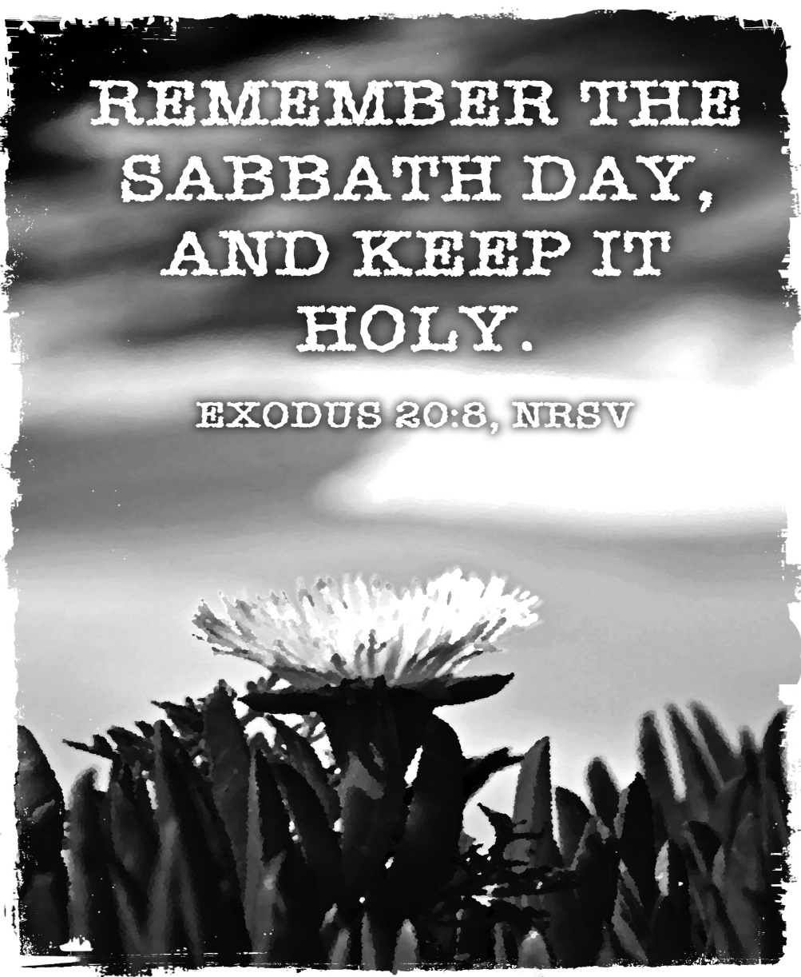
196 East State Rd.
Seneca, PA 16346
sumchurch16346@gmail.com
Pastor’s Cell (610)931-5118
Office (814) 676-1759

