Seneca United Methodist Church
April 25, 2021
FOURTH SUNDAY OF EASTER

Pastor: Rev. Dr. Zayzay Gwepougee Kpadeh
Worship Leader: David Grau 10:00 A.M. Morning Worship
============================================================
Prelude - George Wilbur

Announcements and Welcome
Invocation
Wave of Christian Fellowship
Ministry of the Acolytes and time of Preparation

Praise Song(s) “We Fall Down” “Oh, How He Loves You and Me”
- Keith Silverling, Leader
Call to Worship
L: Jesus is the good shepherd.
P: WITH HIM WE HAVE NOTHING TO FEAR.
L: Jesus is the door.
P: THROUGH HIM WE ENTER THE KINGDOM OF GOD.
L: Jesus is the cornerstone.
P: UPON HIM WE CAN BUILD FOR ETERNITY.

INVOCATION
Receive, God in heaven, our prayer of thanks, for we are a most privileged people.
You have shared with us your life. You have given us an earth on which to live
You have given us food, clothing, and shelter. You have given us family and friends.
You have given us Jesus Christ. What more can we ask? Only that you will hear our prayers and smile upon our grateful worship.

PRAYER OF CONFESSION AND WORDS OF ASSURANCE (ALL):
Some of us, Lord, have lost our sense or your presence, - Yes, we have gathered
here in this church building, and we may have greeted each other with smile when we entered—but there is emptiness, a sense of loss within us. We haven’t prayed much lately; but when we did, it didn’t seem like we were getting through. We suspect that the one who has wandered is not you, but ourselves. As the Good Shepherd, seek us out, call us back from our wanderings, and restore us to the security of your fold.

Words of Assurance
Hear the words of the Good Shepherd: “The thief comes only to steal and kill and destroy; I came that they may have life, and have it abundantly.” (John 10:10)

Scripture Lesson Psalm 23

Time for Tots - Wendy McKain

Offertory
*Response of Praise
Prayers of the People

Scripture Lesson John 10:11-18

*Hymn “O For a Thousand Tongues to Sing” - 57 (P)

Sermon “The Good Shepherd”
- Rev. Dr. Zayzay Gwepougee Kpadeh
LORD’S PRAYER

*Hymn of Response “I Am Thine, O Lord” (vs. 1-3) - 419 (P)

Blessing of the Blankets
*Benediction
*Response “He Is Lord” - 177 (P)
*Postlude
(*Indicates when the Congregation is welcome to stand, if able)

TODAY
–Sunday School – 9:00 – 9:45 a.m.
– Worship Service – 10:00 a.m.
– Racism in the Church – Conference – 2:00 – 4:30 p.m. at the Church (See Insert)
THIS WEEK
- Mon. April 26 – Ladies Bible Study – 6:00 – 7:00 p.m.
- Mon. April 26 – Celebrate Recovery – 7:00 p.m.
- Weds. April 28 - Bible Study – 7:00 p.m.
Sat. April 30 – (CR/CC Training) - Virtual Cross Racial/Cross – Cultural Ministry Spring Training
FUTURE EVENTS
- Sun. May 2 – Sunday School -9:00 – 9:45 a.m.
- Sun. May 2 – Worship Service
- Mon. May 3 – Franklin District Conference at Christ UMC in Franklin – 3:00 - 7:00 p.m.
- Mon. May 3 – Celebrate Recovery – 7:00 p.m.
- Weds. May 5 – Bible Study – 7:00 p.m.
- Sun. May 9 – Sunday School – 9:00 – 9:45 a.m.
- Sun. May 9 – Worship Service – 10:00 a.m. – Happy Mother’s Day!!
-
PLEASE SAY A PRAYER FOR:
Week 1: Joni Baker; Tom and Deb Bernard; Decklin Burkhardt; Derek Collins; Cindy Colwell; Karen Flick; Randy Flick; Tammy Flick (for strength); Family of Ed Geer; Josh Harman; Jack Johnson; Thelma Kauffman; Mary Ann Kaminske; Lydia Kelly; Berta Kennemuth; Jane Kimball; Alma Kinch; Sue Lindey; Larry Lewis; Log Cabin Staff; Peggy Mathers; Jessica McCauley-Rice; Doris Miller; Emily and Cindy Mong; Vickie Morris; Ray Nelson; Roberta Nelson; Janet Olmes; Ryan Oxenham; Joyce Perry; Jessica Ricker; Ben Sanford; Shari Sheatz; Caine Sibble; Marcia Slye; Randy Snyder; Georgie Staab; Gerry Stivanson; Debbie Stoltz; Oscar Stoltz; Marita Strassin; Amber Sunshine; Jeannie Udovic; Unspoken; US Military men and women; Katie Welms; Michelle Sweeney; Eric Whitehill; Judy Ziegler.
Week 2: Jennifer Anderson; Rick Aspetia; Don Bacher; Mike Battin; Renee Battin; Larry Beightol; Alan Cadman; Rick Coast; Callen Cochran; Paula Counselman; Lillian Drozdo; Emma Edwards; Aaron Elliott; Steven Elliott; Randy Flick, Nate Grams; Shirley Harper; Kellie Hawkins; Barbara Manross; John McVay; Mitch-Hill Dairy; Becky Perry; Joyce Riddle; Thomas Riggs; Sharon Sponenburgh; Tera Weinrich; Barb and Rick Wice; Ruth Wilson.
Week 3: Kathy Alden; Shirley Alden; Cody Allaman; Hunter Allaman; Baby Aysa; Clair Bayne; Logan Bemis; Julie Clark; Joe Drozdo; Tony Garways; Richard Hart; Ignite Mission Team; Bishop Cynthia Moore-Koikoi; Danny Moss; Kathie Nunn; Alex Petkavich; Joey Petkavich; Michelle Luntz; Bob Reese; Bill Roxberry; Ron Roxberry; Jim Slye; Scott Smith; Dale Snow; Gabriel Sobina; Bryan Stonis; Richard Swavey; Ron Wenner; Rick Wice; Ruth Wilson; Roberta Winger; Grace Whitling; Helen Young; Justin Zacherl; Fred Ziegler.
Week 4: Shirley Barr; Mary Bean; Denny Custer; First Responders; Rachel Greenway; Health Care Workers; Fran Lafferty; Long-term Care Facility Staff, Residents and Families; Dave McClain; David McVay; Betty Perry; Josiah Peterson; Connie Roxberry; Kim Schubert; Ed and Mary Ann Shreffler; Ruth Sliter; Mark Stanton; Greg and Gina Vanderveen; Betty Weaver; Mary Beth White; Vicki Wilson.; Aaron Elliott; Steven Elliott; Kellie Hawkins; Kay Hines; Barbara Manross; Kathleen Novak; Sherri Rogers; Tracey Slaughenhaupt; Mike Stivanson; Kim Whitehill.
Week 4: Annie; Rick Aspetia; Renee Battin; Beth; Family of Clive Brown; Rick Coast; Callen Cochran; Jack Delahunty; Lillian Drozdo; Aaron Elliott; Steven Elliott; Randy Flick; Kellie Hawkins; Kay Hines; Thelma Kauffman; Barbara Manross; Don Myers; Kathleen Novak; Sherry Rogers; Leroy Schwab; Tracey Slaughenhaupt; Mike Stivanson; Katie 2021
Pastor: Rev. Dr. Zayzay G. Kpadeh
Ministers: Congregation
Organist: George Wilbur
Choir Pianist: George Wilbur
Children’s Church: Jenny Jack
April Greeters: TBA
April Ushers: TBA
Welcome Connection Center

“With what shall I come before the Lord and bow down before the exalted God? Shall I come before him with burnt offerings, with calves a year old? ⁷ Will the Lord be pleased with thousands of rams, with ten thousand rivers of olive oil? Shall I offer my firstborn for my transgression, the fruit of my body for the sin of my soul? ⁸ He has shown you, O mortal, Reflection for February walk humbly^{[a]} with your God”(Micah 6:6-8)(NIV).

REFLECTION FOR APRIL

“He’s only my rock and my salvation, my fortress; I shall not be shaken”
(Psalm 62:6) NIV

SENECA UNITED METHODIST CHURCH
APRIL 25, 2021
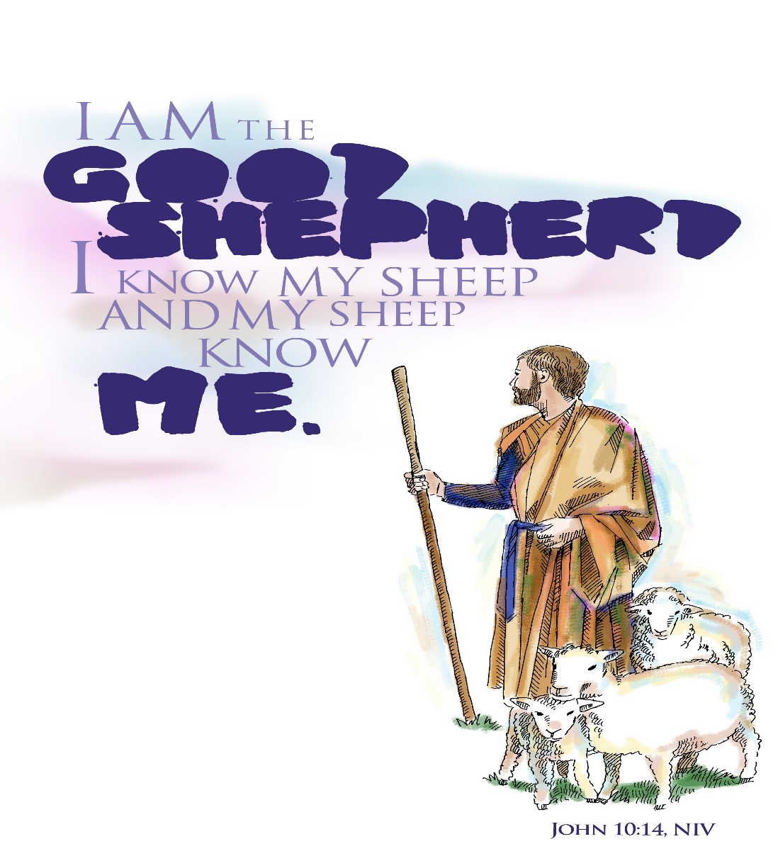

196 East State Rd.
Seneca, PA 16346
Sumchurch16346@gmail.com
Pastor’s Cell (610) 931-5118
Office (814) 676-1759

